2022 Discretionary Grant Application

*Saint Luke's Foundation*

# Grant Information

## Discretionary Grant Application

**Discretionary grants** are accepted and approved on a rolling basis. Applicants will be notified of a decision within four weeks of submission.

Please visit our [What We Fund](https://www.saintlukesfoundation.org/grants/what-we-fund) page for more information on our decision making process.

###### As is the case with all kind of grantmaking the Foundation does, a conversation with a member of the program staff will be required before submitting an application. This can take place over the phone. [Click here](mailto:ajohnson@stlukesfdn.org) to email us and set up a meeting now.

If you have any questions or concerns about the application or the process, please contact the Grants Team at 216-431-8010 or [grants@stlukesfdn.org](mailto:grants@stlukesfdn.org)

**Project Title\***

Please provide a title for your request

*Character Limit: 100*

### Amount Requested*

Amount Requested

*Character Limit: 20*

#### Please visit our [What We Fund](https://www.saintlukesfoundation.org/grants/what-we-fund) page for detailed information on how we provide funding within our footprint and throughout Cuyahoga County.

SLF Footprint Map

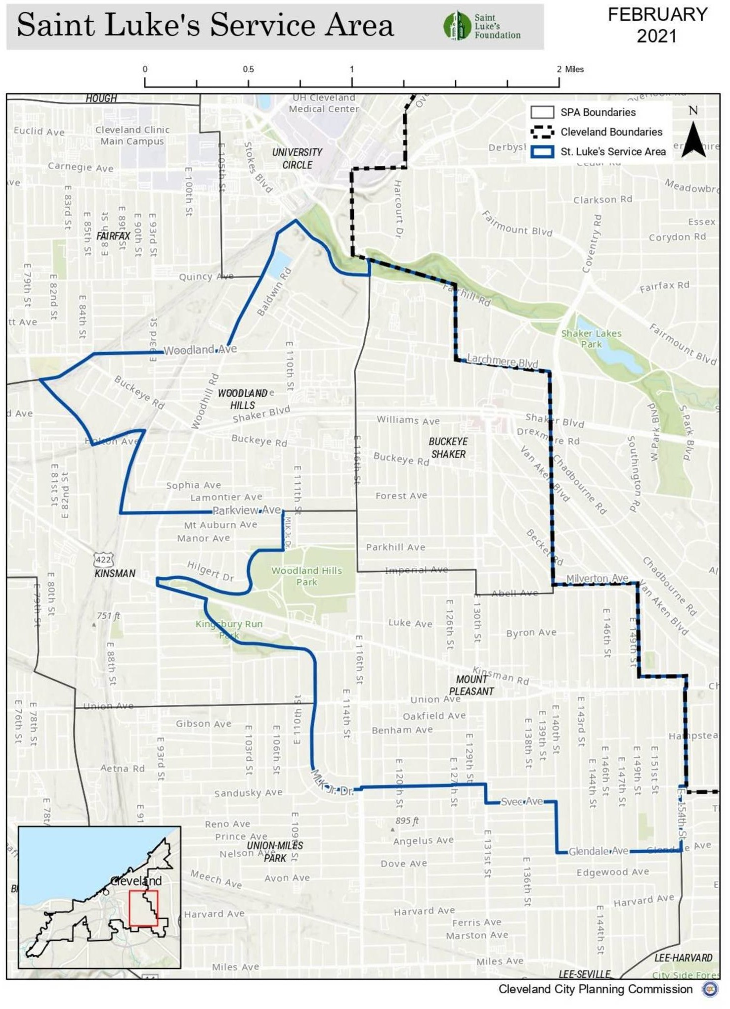

You can also visit [this link](https://www.saintlukesfoundation.org/files/pages/scale/crop/stlukesserviceareamapsv1.jpg) for a larger version of this map.

### SLF Footprint Neighborhoods

Please indicate which Saint Luke's Foundation footprint neighborhood(s) your work will serve and/or engage.

**Choices** Buckeye/Shaker Buckeye/Woodhill Mt. Pleasant

### Type of Support*

Please indicate the type(s) of support you are requesting with this grant proposal.

##### Capacity building examples include: leadership development, improving evaluation and outcomes measurement, enhancing advocacy involvement, improving communications and collaborations.

###### Choices

General Operating Program/Project Support Capital Support

Capacity Building

# Narrative

## Proposal Narrative

#### Equity Statement

Saint Luke's Foundation is committed to racial equity. **Within your answers, please address these questions about your work:**

* What is your overall organization's understanding of Diversity, Equity and Inclusion, and how are these values incorporated into your work?
* How are you connected to the population you intend on serving and how is the proposed scope guided by that population? In other words, how do you know the community wants this service?
* Are people of the served population involved in service delivery? If so, how and to what extent?
* How does the demographic makeup of your organization and leadership team relate to the demographic makeup of those you intend on serving with this grant award?
* What economic opportunities would the grant funds present to stakeholders of the community served? Hence, where is the money landing and is some of it landing within the community?

*We have extended our character limits. Please do not feel you need to fill the space.*

**Population Served and Project Rationale\***

Please describe the population you are planning to serve with this grant request, and include details on demographics and geography, as applicable. What is the need or opportunity to be addressed within this population?

##### Please keep in mind the equity questions above.

*Character Limit: 5000*

### Project Description*

How do you propose to address the need or opportunity described above? Explain why you feel this is the best approach.

##### Please keep in mind the equity questions above.

*Character Limit: 5000*

### Anticipated Results/Deliverables*

Please describe the results you anticipate during the project and after its completion. These should describe your plan to answer both of the following questions:

###### How much or how many and how often over the grant period?

For example:

* 12 individuals each attending 8-session series of workshops or receiving 10 hours of one-to-one assistance in each quarter of the grant period, or
* 30 families receiving bags of produce and healthy recipes for 10 meals each month

###### What will success look like and how will you measure it?

For example:

* 75% of individuals attending >6 of 8 sessions will demonstrate positive behavior changes, measured using the “brief ABC scale” administered before and after the series,
* 80% of families receiving produce bags reported they had tried and would eat healthy recipes again

*Character Limit: 5000*

# Financial Information

### Project Budget--Cost Breakdown*

Please identify specific project costs and associated dollar amounts. What will the requested funds be used for?

*Character Limit: 3000*

### Project Budget--Funding Sources*

Please let us know other funding sources and amounts *for this project only*.

*Character Limit: 2000*

### Organization Budget Total*

Please enter the total amount of your organization's operating budget here.

*Character Limit: 20*

### Audited Financials*

Please attach your most recently audited financial statements, or your 990 if you do not have audited financial statements.

*File Size Limit: 5 MB*

# Further Information (Optional)

### OPTIONAL File Upload

This is an optional section for applicants wishing to add any additional documentation with their request.

###### You can attach only one file at a maximum of 5MiBs. To merge several PDFs together for free, please visit [I Love PDF.](https://www.ilovepdf.com/merge_pdf)

*File Size Limit: 5 MB*