2022 Board Grant Application

*Saint Luke's Foundation*

# Request Summary

### Saint Luke's Foundation 2021 Board Grant Application

Thank you for taking the time to complete our application. Please submit your application by

**11:59 p.m**. on the deadline date for the cycle. Our deadlines for 2022 are:

* **2nd Quarter: March 14, 2022** (decision at board meeting mid-June)
* **3rd Quarter: June 13, 2022** (decision at board meeting early September)
* **4th Quarter: September 12, 2022** (decision at board meeting early December)

Please visit our [What We Fund](https://www.saintlukesfoundation.org/grants/what-we-fund) webpage for detailed information on our grantmaking decision logic.

If you have any questions or concerns about the application or the process, please contact the Grants Team at 216-431-8010 or [grants@stlukesfdn.org](mailto:grants@stlukesfdn.org)

**Project Name\***

Name of Project

*If you are requesting general operating support for your organization, please enter "Operating Support".*

*Character Limit: 100*

## Project Description

Please provide a short description of your project.

*General Operating requests--you may skip this*

*Character Limit: 500*

## Total Amount Requested*

*Character Limit: 20*

## Payable in Year 1*

Please enter the requested amount requested for year one. If this is a single-year request, this amount should match the total amount requested.

*Character Limit: 20*

## Payable in Year 2

For multi-year requests only.

*Character Limit: 20*

## Payable in Year 3

For multi-year requests only.

*Character Limit: 20*

## Term Months Requested*

How many months of funding are you seeking? Answers are typically in multiples of 12 months (1year).

*Character Limit: 10*

## Type of Support*

Please indicate the type(s) of support you are requesting with this grant proposal.

*Capacity building examples include: leadership development, improving evaluation and outcomes measurement, enhancing advocacy involvement, improving communications and collaborations.*

**Choices**

General Operating Program/Project Support Capital Support

Capacity Building

Please visit our [What We Fund](https://www.saintlukesfoundation.org/grants/what-we-fund) page for detailed information on how we provide funding within our footprint and throughout Cuyahoga County.

SLF Footprint Map

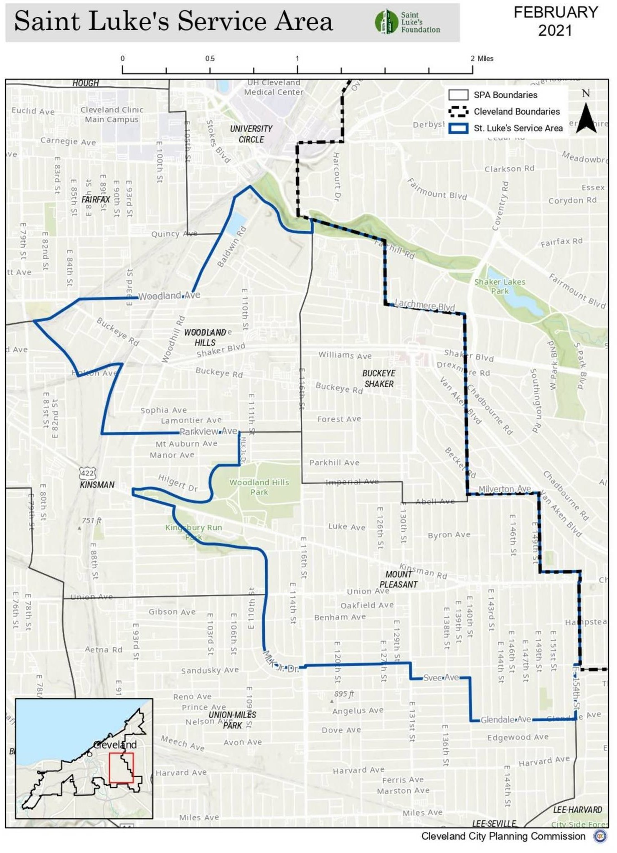

You can also visit [this link](https://www.saintlukesfoundation.org/files/pages/scale/crop/stlukesserviceareamapsv1.jpg) for a larger version of this map.

## SLF Footprint Neighborhoods

Please indicate which Saint Luke's Foundation footprint neighborhood(s) your work will serve and/or engage.

**Choices** Buckeye/Shaker Buckeye/Woodhill Mt. Pleasant

## Closest Address

If this work serves people in a physical location, please indicate the address where most of the work will take place.

*Character Limit: 250*

# Internal Data Collection

## Primary Staff Responsible INTERNAL

Program Officer/Lead staff

**Choices**

Christie Manning

Indigo Bishop Peter Whitt Tim Tramble

## Grant Focus INTERNAL

What is the focus of **this grant request**?

The organization may focus on both, but please answer based on what we would fund.

**Choices**

Client Focused System Focused Both

Other

## Say Yes to Education Code INTERNAL

If this grant serves Cleveland kids, either within or outside school (charters and private included), select appropriate code below.

Key:

* K-12 = within K-12 schools
* ECE = Early Childhood Education
* Post-Sec = Post Secondary
* Soc-Emo = Social/Emotional (Parent Engagement falls here)
* HWB = Health and Well-being

**Choices**

K-12 New Schools and School Design K-12 Charter School Supports

K-12 Student academic support, including tutoring K-12 College access

K-12 Staff recruiting/talent development K-12 Private/religious school supports

K-12 Services for students with disabilities K-12 STEM Enrichment

K-12 Staff professional development K-12 Arts/Music

K-12 Other

ECE Literacy Supports

ECE Quality Seat Expansion ECE Capacity-building

ECE Staff professional development ECE Preschool subsidies

ECE Advocacy ECE Pre-natal

ECE Parent education ECE Lead

ECE Home visits ECE Other

Post-Sec Scholarships Post-Sec Instruction Post-Sec Persistence Post-Sec Other

Soc-Emo Out-of-School Time

Soc-Emo Workforce Development Soc-Emo Mentoring

Soc-Emo Capacity-building Soc-Emo Other

HWB Health Care (Mental Health,Dental, Vision, Etc.) HWB Capacity-Building

HWB Family stability, including reentry services HWB Food & Clothing

HWB Prevention/Protection HWB School-based coordination HWB Policy

HWB Child homelessness HWB Advocacy

HWB Reproductive Health/Family Planning

# Organization Details

The questions in this section will help us get to know your organization and its successes.

*We have increased our character limits across the application to be more flexible, but please do not feel that you need to fill the space.*

**Mission Statement\***

Please include your organization's mission statement.

*Character Limit: 250*

## Mission Achievement*

Please give us an overview of your organization. Where does your organization fit into the landscape of services?

*Character Limit: 5000*

# Equity Questions

Saint Luke's Foundation is committed to racial equity. The next questions will help us understand how your organization implements equitable practices.

**Equity Question #1\***

How are you creating a racial equity culture in your organization and how is it embodied in your work?

*Character Limit: 3000*

## Equity Question #1 INTERNAL

Does this answer indicate the organization is approaching equity?

**Choices**

Yes No

Making Progress

## Equity Question #2*

How is your organization connected to those you intend to serve? How do you involve them in program design, delivery and evaluation to ensure that your programs and services meet their needs and capitalize on their assets?

*Character Limit: 3000*

## Equity Question #2 INTERNAL

Does this answer indicate the organization is approaching equity?

**Choices**

Yes No

Making Progress

## Equity Question #3*

What economic opportunities would the grant funds offer stakeholders of the community served? What funds will remain in the community served?

*Character Limit: 3000*

## Equity Question #3 INTERNAL

Does this answer indicate the organization is approaching equity?

**Choices**

Yes No

Making Progress

Please provide the demographic information below:

## Racial/Ethnic demographic of your Executive Director*

**Choices**

White

Black or African American Latinx (Latin American Descent)

Indigenous Peoples (American Indian or Alaska Native) Asian (Chinese, Vietnamese, Korean, Japanese)

Pacific Islander (Native Hawaiian, Samoan, Chamorro) Other

## Racial/Ethnic makeup of your Board of Directors (in percentages)*

Copy and paste the following list into your answer, and then indicate the percentage for each category, to total 100%.

**White:**

**Black or African American:**

##### Latinx (Latin American Descent):

**Indigenous Peoples (American Indian or Alaska Native):**

##### Asian (Chinese, Vietnamese, Korean, Japanese):

**Pacific Islander (Native Hawaiian, Samoan, Chamorro):**

##### Other:

**Total:**

*Character Limit: 1000*

## Racial/Ethnic makeup of your Leadership Staff (in percentages)*

Copy and paste the following list into your answer, and then indicate the percentage for each category, to total 100%.

**White:**

**Black or African American:**

##### Latinx (Latin American Descent):

**Indigenous Peoples (American Indian or Alaska Native): Asian (Chinese, Vietnamese, Korean, Japanese):**

##### Pacific Islander (Native Hawaiian, Samoan, Chamorro): Other:

**Total:**

*Character Limit: 1000*

## Racial/Ethnic makeup of your Staff (in percentages)*

Copy and paste the following list into your answer, and then indicate the percentage for each category, to total 100%.

**White:**

**Black or African American:**

##### Latinx (Latin American Descent):

**Indigenous Peoples (American Indian or Alaska Native):**

##### Asian (Chinese, Vietnamese, Korean, Japanese):

**Pacific Islander (Native Hawaiian, Samoan, Chamorro):**

##### Other:

**Total:**

*Character Limit: 1000*

## Racial/Ethnic makeup of Population Served (in percentages)*

Copy and paste the following list into your answer, and then indicate the percentage for each category, to total 100%.

**White:**

**Black or African American:**

##### Latinx (Latin American Descent):

**Indigenous Peoples (American Indian or Alaska Native):**

##### Asian (Chinese, Vietnamese, Korean, Japanese):

**Pacific Islander (Native Hawaiian, Samoan, Chamorro):**

##### Other:

**Total:**

*Character Limit: 1000*

# Proposal

Proposal Details

**Project Rationale/Problem Statement\***

What is the need or opportunity to be addressed?

*Character Limit: 5000*

## Population Served*

Please describe the population you are planning to serve with this grant request. Please include details on demographics and geography, particularly referencing the SLF Footprint Neighborhoods.

*Character Limit: 5000*

## Implementation Plan*

How do you propose to address the need or opportunity described above? Explain why you feel this is the best approach.

Please include a bulleted list of activities to take place each quarter or a timeline, as appropriate.

*Character Limit: 5000*

Deliverables/ Anticipated Results Statement

This section addresses the intended results once your implementation plan is executed. Only one set of deliverables and results statement is required; however, you may add up to 3 additional if it makes sense to describe separately, and if all are clearly aligned with the foundation’s strategies.

Please use the box(es) below to describe your anticipated results and specific, measurable deliverables. Please attend to these questions in that description:

* How much and/or how many?
* What will success look like?
* How will you measure it and what is your baseline, if appropriate? Following are a few examples which include the appropriate elements:

Example 1:

*Following outreach and engagement described in the Implementation Plan section, we expect to improve family engagement in children’s education among 48 unduplicated families over the course of the year. We will serve 4 groups of 12 families each, participating in an 8-session series of workshops, and each receiving 6-10 hours of individualized assistance in working towards their family goals. The anticipated results for these families include increased family engagement and agency in their children’s education and development, measured by changes on the “brief ABC scale” administered pre- and post-participation; and progress towards achievement of at least 1 individualized learning goal per family, measured by self-report and rating on a 5 point scale administered pre- and post-participation.*

Example 2:

#### We will engage at least 50 city of Cleveland residents, currently unemployed or underemployed, in community conversations about the barriers they face to securing and maintaining family sustaining wage employment. These conversations will drive the

*development of informational materials related to workforce policy, which will be shared with policy makers along with live or recorded testimony of at least 5 engaged and impacted residents. We will also incorporate content from resident testimony into the production of at least 10 policy briefs, 10 articles published via mainstream media outlets, and see at least 500 social media hits related to advancing more equitable workforce policies.*

Example 3:

*We will engage our board and staff in a process to deepen our capacity to advance equity through our work. 100% of our staff and 80% of our board members will participate in the 2- day REI groundwater training, following which a committee of Board and staff will be formed to develop organizational policies and practices that support increased inclusion and equity, both internally and externally. This work will not yield final results in the one-year grant period, but we expect to measure our progress by completing a detailed plan of next steps for the following year, and the identification or development of tools to assess our progress at least yearly.*

## Deliverable #1*

*Character Limit: 4000*

## Deliverable #1 Allocation*

What approximate percentage of this grant is going toward this deliverable?

*Character Limit: 100*

## Deliverable #1 Strategy INTERNAL*

**Choices**

Educational Attainment - Family Engagement Educational Attainment - Early Childhood Educational Attainment - Post-secondary Financial Stability - Employment Access Financial Stability - Public Benefits

Financial Stability - Asset Building

Housing Safety & Stability - Affordable Housing Access Housing Safety & Stability - Safety and Quality

Social Connections

Healthy Eating, Active Living - Food

Healthy Eating, Active Living - Spaces and Places Healthy Eating, Active Living - Healthy Behaviors

SLF Neighborhoods of Choice - Physical Enhancements SLF Neighborhoods of Choice - Commercial Corridors

SLF Neighborhoods of Choice - Eliminate Residential Blight SLF Neighborhoods of Choice - Improve Safety

SLF Neighborhoods of Choice -Social-Emotional Wellbeing Advocacy/Policy - Health Equity/Social Determinants Advocacy/Policy - Healthcare Access Other/Miscellaneous

## Deliverable #1 Socio-Ecological Model INTERNAL

[More info](https://www.acha.org/HealthyCampus/HealthyCampus/Ecological_Model.aspx)

**Choices** Self/Individual/Intrapersonal Interpersonal Institutional/Organizational Community

Public Policy

## Deliverable #2

*Character Limit: 4000*

## Deliverable #2 Allocation

What approximate percentage of this grant is going toward this deliverable?

*Character Limit: 100*

## Deliverable #2 Strategy INTERNAL

**Choices**

Educational Attainment - Family Engagement Educational Attainment - Early Childhood Educational Attainment - Post-secondary Financial Stability - Employment Access Financial Stability - Public Benefits

Financial Stability - Asset Building

Housing Safety & Stability - Affordable Housing Access Housing Safety & Stability - Safety and Quality

Social Connections

Healthy Eating, Active Living - Food

Healthy Eating, Active Living - Spaces and Places Healthy Eating, Active Living - Healthy Behaviors

SLF Neighborhoods of Choice - Physical Enhancements SLF Neighborhoods of Choice - Commercial Corridors

SLF Neighborhoods of Choice - Eliminate Residential Blight SLF Neighborhoods of Choice - Improve Safety Advocacy/Policy - Health Equity/Social Determinants

SLF Neighborhoods of Choice -Social-Emotional Wellbeing Advocacy/Policy - Healthcare Access Other/Miscellaneous

## Deliverable #2 Socio-Ecological Model INTERNAL

**Choices** Self/Individual/Intrapersonal Interpersonal Institutional/Organizational Community

Public Policy

## Deliverable #3

*Character Limit: 4000*

## Deliverable #3 Allocation

What approximate percentage of this grant is going toward this deliverable?

*Character Limit: 100*

## Deliverable #3 Strategy INTERNAL

**Choices**

Educational Attainment - Family Engagement Educational Attainment - Early Childhood Educational Attainment - Post-secondary Financial Stability - Employment Access Financial Stability - Public Benefits

Financial Stability - Asset Building

Housing Safety & Stability - Affordable Housing Access Housing Safety & Stability - Safety and Quality

Social Connections

Healthy Eating, Active Living - Food

Healthy Eating, Active Living - Spaces and Places Healthy Eating, Active Living - Healthy Behaviors

SLF Neighborhoods of Choice - Physical Enhancements SLF Neighborhoods of Choice - Commercial Corridors

SLF Neighborhoods of Choice - Eliminate Residential Blight SLF Neighborhoods of Choice - Improve Safety

SLF Neighborhoods of Choice -Social-Emotional Wellbeing Advocacy/Policy - Health Equity/Social Determinants Advocacy/Policy - Healthcare Access Other/Miscellaneous

## Deliverable #3 Socio-Ecological Model INTERNAL

**Choices** Self/Individual/Intrapersonal Interpersonal Institutional/Organizational Community

Public Policy

## Deliverable #4

*Character Limit: 4000*

## Deliverable #4 Allocation

What approximate percentage of this grant is going toward this deliverable?

*Character Limit: 100*

## Deliverable #4 Strategy INTERNAL

**Choices**

Educational Attainment - Family Engagement Educational Attainment - Early Childhood Educational Attainment - Post-secondary Financial Stability - Employment Access Financial Stability - Public Benefits

Financial Stability - Asset Building

Housing Safety & Stability - Affordable Housing Access Housing Safety & Stability - Safety and Quality

Social Connections

Healthy Eating, Active Living - Food

Healthy Eating, Active Living - Spaces and Places Healthy Eating, Active Living - Healthy Behaviors

SLF Neighborhoods of Choice - Physical Enhancements SLF Neighborhoods of Choice - Commercial Corridors

SLF Neighborhoods of Choice - Eliminate Residential Blight SLF Neighborhoods of Choice - Improve Safety

SLF Neighborhoods of Choice -Social-Emotional Wellbeing Advocacy/Policy - Health Equity/Social Determinants Advocacy/Policy - Healthcare Access Other/Miscellaneous

## Deliverable #4 Socio-Ecological Model INTERNAL

**Choices** Self/Individual/Intrapersonal Interpersonal Institutional/Organizational Community

Public Policy

## Other Strategies INTERNAL

Does the work of this organization address any of our other strategies not already specified in the results statements above?

**Choices**

Educational Attainment - Family Engagement Educational Attainment - Early Childhood Educational Attainment - Post-secondary Financial Stability - Employment Access

Financial Stability - Public Benefits Financial Stability - Asset Building

Housing Safety & Stability - Affordable Housing Access Housing Safety & Stability - Safety and Quality

Social Connections

Healthy Eating, Active Living - Food

Healthy Eating, Active Living - Spaces and Places Healthy Eating, Active Living - Healthy Behaviors

SLF Neighborhoods of Choice - Physical Enhancements SLF Neighborhoods of Choice - Commercial Corridors

SLF Neighborhoods of Choice - Eliminate Residential Blight SLF Neighborhoods of Choice - Improve Safety

SLF Neighborhoods of Choice -Social-Emotional Wellbeing Advocacy/Policy - Health Equity/Social Determinants Advocacy/Policy - Healthcare Access Other/Miscellaneous

## Update on Funding

##### *ONLY FOR THOSE WHO HAVE A CURRENT GRANT WITH SAINT LUKE'S*

If we have funded you prior for this work, please provide an update on that funding.

*Character Limit: 3000*

## Responsible Staff*

Please describe the full-time/part-time roles involved in the project and specifics about the staff responsible, including unique qualifications and whether demographics correspond to the population served.

*Character Limit: 2500*

## Partners and Collaborators*

Who is helping you do this work? Please include a bulleted list of your partners and their roles.

*Character Limit: 2500*

# Required Documents

## Board List*

Please upload a list of your board members, excluding any personal contact information.

*File Size Limit: 2 MB*

## Organization Chart*

Please upload your organizational chart, including names and titles.

*File Size Limit: 2 MB*

## Audited Financials*

Please submit your most recent organizational audit, along with the auditor's management letter (or memorandum of internal controls). If you do not have an audit, please submit a letter from your financial advisor indicating the current financial status of your organization.

*File Size Limit: 5 MB*

## Project Budget and Narrative

Please upload a budget, in your own format, for the project or capital request.

Also, in the box below or in the document, please provide information on any other funders for this project and the amounts they have committed or are pending.

*Character Limit: 2500 | File Size Limit: 3 MB*

## Organization Budget*

Please upload the overall budget of the organization. Also, in the box below, please describe the financial health of the organization, including any anomalies.

*Character Limit: 2500 | File Size Limit: 3 MB*

## Organization Budget Total*

What is your organization's total operating budget?

*Character Limit: 20*

## Optional Documents

OPTIONAL: You may upload any additional documents here (must be one file). This could include your strategic plan, or any documents relevant to the proposal at hand.

**You can attach only one file at a maximum of 7 MiBs. To merge several PDFs together for free, please visit** [**I Love PDF.**](https://www.ilovepdf.com/merge_pdf)

*File Size Limit: 7 MB*

# Feedback to Saint Luke's

## Hours Required*

Approximately how many hours did it take you to complete this grant application? *Please include the time it took to prepare any documents you needed for this specific application.*

**Choices**

0-5 hours

6-10 hours

11-15 hours

16-20 hours

20+ hours